Oyster Task Force Meeting
Tuesday, March 19, 2024, 10:00am
LDWF Headquarters
2000 Quail Drive
Baton Rouge, LA 70898

I. Pledge of Allegiance
II. Roll Call and introduction of guests
Voting Members Present:
Shane Bagala
Jakov Jurisic
Brad Robin
Mitch Jurisich
Brandt Lafrance
Al Sunseri
Sam Slavich
Peter Vujnovich
Willie Daisy
Steve Pollock

Voting Members Absent:
Tracy Collins
Dan Coulon
Brandon Debarge
Matthew Slavich

Non-Voting Members Present:
Robert Caballero
Edward Skena
Kyle Balkum
Brian Lezina

Non-Voting Members Absent:

III. Peter Vujnovich motioned to approve the February 6, 2024 meeting minutes as presented, 2nd by Jakov Jurisic. Motion carries.

Peter Vujnovich motioned to amend the agenda by adding item A. To Hear an Update on the Restore Program and item H. To Consider Supporting the Continuation of a Documentary Regarding the BP Oil Spill and the Aftermath, under New Business, 2nd by Brad Robin. Motion carries.

Peter Vujnovich motioned to approve the agenda as amended, 2nd by Brad Robin. Motion carries.

IV. Treasury Report
Fund Balance- $568,335
Budget Balance- $36,493

Peter Vujnovich motioned to approve the financial report as presented, 2nd by Willie Daisy. Motion carries.

Committee Reports:
- Public Private Oyster Seed Grounds Committee- no report
- Enforcement Report- Edward Skena provided the enforcement report
January 26th- March 11th
Region 4 (Iberia)
None

Region 5 (Calcasieu, Cameron, Vermillion)
Vermillion
2-56:449E Possess less than 10% untagged oyster sacks
1-56:307 Transport W/O Required License (associated with shipment of oysters)
Seizures- 4 Sacks

Region 6: (Terrebonne, Lafourche, Grand Isle)
Terrebonne
7- 40:4A Violate sanitation code (logbook)
3-56:444 Failure to display proper number on vessel
3-56:433.1 Violate seed ground vessel permit
3-56:303.2 Fail to have commercial license in possession (No oyster harvester)
3-56:303.2 Fail to have commercial license in possession (Seed ground permit)
3-56:303.2 Fail to have commercial license in possession (Seed ground gear permit)
3-56:436 Take oysters illegal hours
3-56:424E(1) Taking oysters from unapproved area (polluted)
Seizures: 50 Sacks

Region 8: (Jefferson, Plaquemines, St. Bernard, Orleans)
St. Bernard
2- 56:424 E(1) – Take Oysters From Unapproved Area
1-40:4A Violate Sanitation Code (log Book)
1-56:303.2A – Fail to Have Commercial Licenses in Possession
1-40:4A – Violate Sanitation Code (Refrigeration)
Seizures: 102 Sacks

- Legislative Report- no report; Sam Slavich stated that the Oyster Lease Damage Evaluation Board has some proposed changes to legislation that governs that board. The legislation would seek to have one oyster industry person and one from the oil and gas industry to constitute a quorum
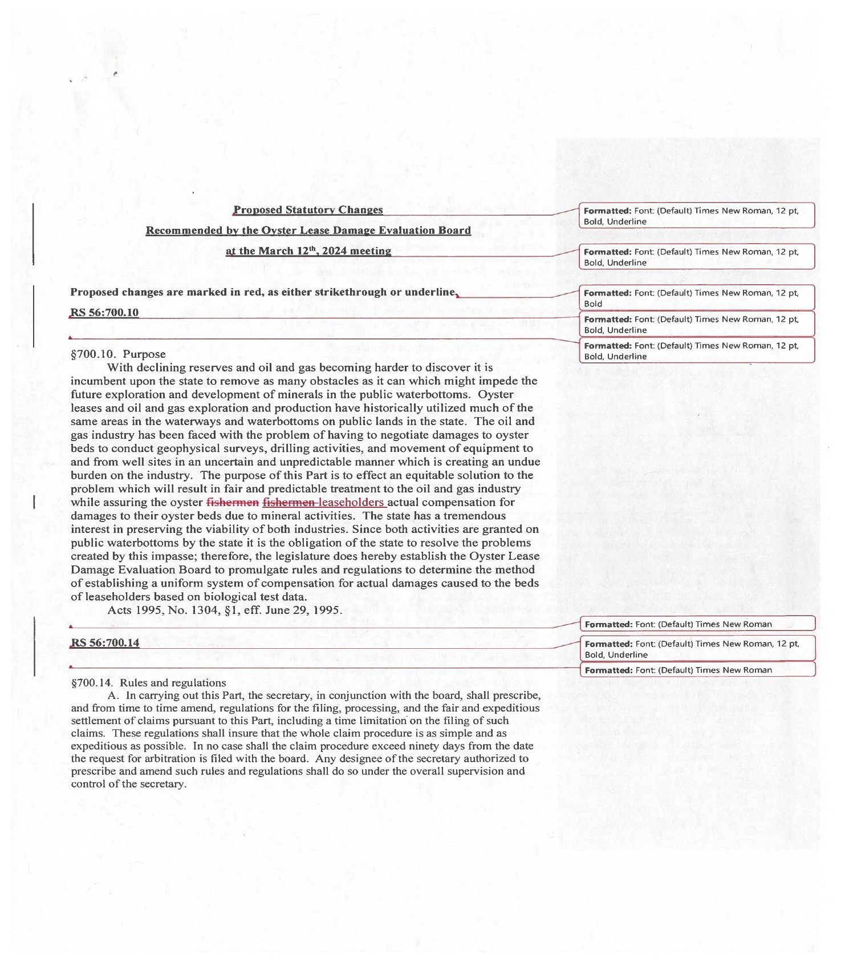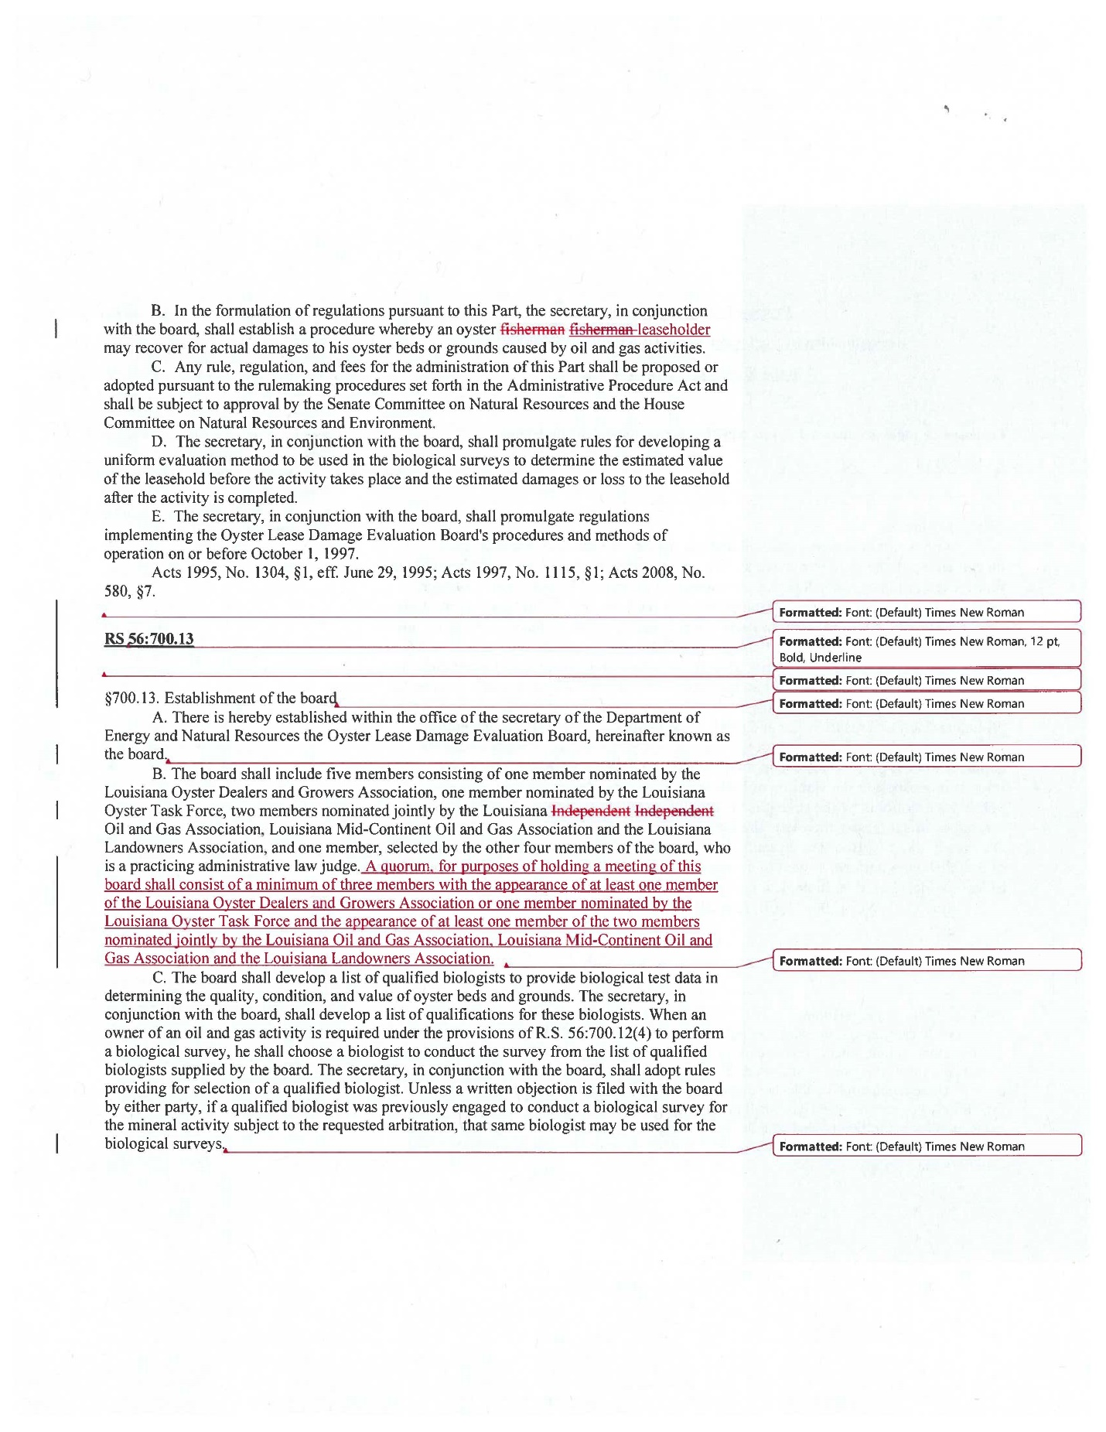Sam Slavich motioned to accept the proposed statutory changes to the Oyster Lease Damage Evaluation Board , 2nd by Peter Vujnovich. Motion carries.
- Legal Report- no repot
- Research Report- no report
- Coastal Restoration Report- no report
- Marketing Report- Anna Koehl stated that BMF conducted the digital campaign targeting the Gulf Oyster Symposium and the paid email is awaiting final review once that goes out we will be able to look at the full results and provide the task force with an update at the next meeting; Jakov Jurisic stated that he made several attempts to reach out to the LT Governor’s office and has not heard back; SPMB provided opinions on Mid-Barataria Sediment Diversion at the last CPRA meeting
- Health Report- Jennifer Armentor provided a health committee report
There has only been one illness since our last meeting, which brings our total for the year to 2. It was Vibrio parahemoliticus. It was one individual who ate at three New Orleans restaurants so we had to go through a lot tags. Looking into areas 3, 4, 14, and 15 and Virginia and Maryland. The restaurant was cited for temperature and one oyster bar that was not permitted, could have been a few different things.

Al Sunseri stated that they happened to be having a health inspection today and the inspector notified them that they should be doing temperature checks on their coolers on the weekends and twice a day. Would like to make an inquiry to the ISSC to see what determined this change to seven days a week, two times a day
Jennifer Armentor stated that this is correct that it was an NSSP Model Ordinance so the cooler regulations have changed, used to say coolers must be checked twice a day when product is present during normal operating hours and that part was removed. If you have product present on Saturdays, Sundays, holidays you have to record it twice; if you have continuous monitoring you would have to have your monitoring records available to LDH and you have to record the temperature once a day
Aquaculture Report- no report; Steve Pollock stated that as a sitting voting member on the Oyster Task Force, as the chair of the subcommittee for aquaculture and the President of Louisiana Oyster Agriculture Association and a board member for the ISSC I'd appreciate in future if there's anything that's going to come up like Item C. on AOC containers in unapproved areas that I at least I'd be made aware of it before it goes as a bill to state legislature so that I can try to talk to my people, try to educate my people and not have such redundancy
- Joint Task Force Working Group Report- no report
VI. New Business:
A-1. Cullen Curole provided the task force with an update on the Restore Small Business Loan Program
- Small Business Program Objectives: To assist disaster-impacted small businesses with non-construction expenses
- To aid in the recovery of small businesses and non-profits located in eligible areas that were affected by Hurricanes Laura and Delta
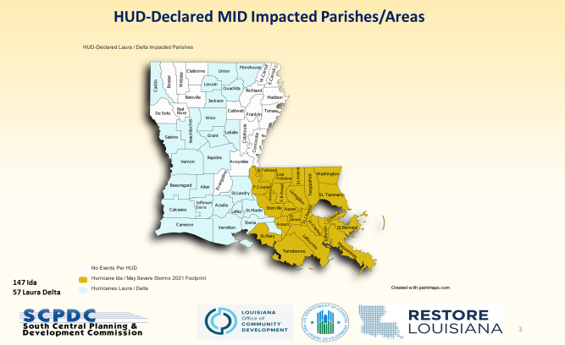
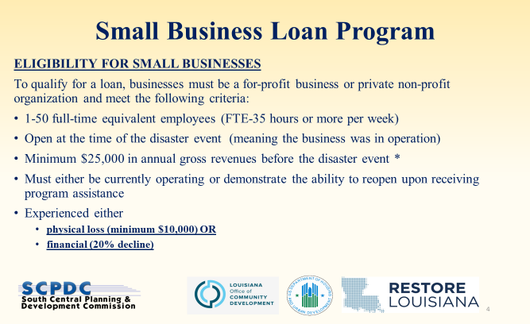
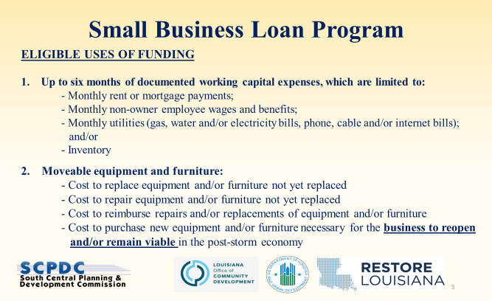
Award Structure and Loan Terms:
LOAN TERMS
- Loan Values between $10,000 to $150,000 (with exceptions to $250,000)
- Interest rate is 0%.
- 60% of the loan will be amortized over seven (7) years, following a six-month period of no principal repayment.
- The loan is structured as 60% repayable and 40% forgivable.
A-2- Robert Caballero provided an oyster season update
Oyster Task Force meeting Oyster Season Summary
Below is a comprehensive update for the Oyster Season. Daily reporting estimates are up to 3/15/2024 and biologist board run estimates are up 3/15/2024.

Daily Reporting
Below is the table with the daily reporting data. It appears that some of the phone reporting converted over to the eReporting application. Also, the eReporting application has many of the out of state vessel permit users. Total reporting compliance across the state is estimated at 55%, by comparing total harvest vessels observed by biologists versus total vessels complying with daily reporting. Of the 147 vessels daily reporting, 83% are phone reporting and 27% are using the new eReporting app. *The total vessels observed data still needs further error checks, this number may come down after complete data review.

Total Vessels Reporting | 147 | 55%
Total Vessels Observed | 265*
Total Vessels Phone call | 122 | 83%
Total Vessels eReporting | 39 | 27%

POSG East of Mississippi River and North of MRGO
6,395 sacks reported harvested through daily reporting requirement. Biologist boarding run estimates put the harvest around 10,385 sacks. There is a 38% difference in daily reported harvest versus boarding run harvest estimates for this area. Most of the harvest has taken place In LDH areas 2 & 3, in the northern Biloxi Marsh area. Total harvest for the area has reached 38% of the total Shell Budget thresholds, however two reefs have exceeded the individual reef harvest thresholds. The 3-Mile Pass and Shell Point cultch plants have exceeded their 50% Fishery Management Plan harvest threshold and Shell Budget harvest thresholds. Closure of these two reefs occurred ½ hour after sunset on 12/03/2023. Harvest in this area has dropped off since the end of December, with only a few boats still participating sporadically. Daily reporting compliance by harvesting vessels is compiled by comparing total harvesting vessels observed by biologists versus total vessels complying with daily reporting. The oyster season compliance estimates so far are at 74% of the vessels reporting and 71% of harvested sacks reported.

POSG East of Mississippi River and South of MRGO
A total of 2,052 sacks have been reported harvested through the daily reporting requirement. Biologist boarding run estimates put the harvest around 2,979 sacks. There is a 31% difference in daily reported harvest versus boarding run harvest estimates for this area. All of the Harvest for this area is coming from around the clutch plant in Lake Fortuna. Total harvest for the area has reach 21% of the total Shell Budget Thresholds. Daily reporting compliance by harvesting vessels estimates so far are at 80% of the vessels reporting and 70% of harvested sacks reported.

Sister Lake
There were 24,632 sacks reported of market oysters harvested through the daily reporting requirement. Biologist boarding run estimates put the market harvest around 34,921 sacks. There is a 29.5% difference in daily reported harvest versus boarding run harvest estimates for this area. Most of the harvest came from northern side of the lake and the cultch plants around mid-lake. Sister Lake was open for 20 fishable days and historically is managed through repeated smaller openings. LDH closure lines have extended into Sister Lake, closing some of the more productive northern reefs from November-February. There were 118 vessels participated in this harvest opening. Daily reporting compliance by harvesting vessels for the oyster season averages are at 61% of the vessels reporting and 62% of harvested sacks reported.
The second opening of Sister Lake was from March 4 through March 10, for 7 fishable days with 6,536 sacks reported of market oysters harvested through the daily reporting requirement. Biologist boarding run estimates put the market harvest around 16,182 sacks. There is a 60% difference in daily reported harvest versus boarding run harvest estimates for this area. Most of the harvest came from the cultch plants in the lake, Grand Pass reef, and the Bayou Dularge reef area. There were 107 vessels participating in this harvest opening, with 70 new vessels participating for the current season. The second opening daily reporting compliance by harvesting vessels averaged 57% of the vessels reporting and 59% of harvested sacks reported.
Several inquiries have been made by interested oyster industry groups for continued harvest of this area. The recent oyster harvest estimates and biological dredge data is being assessed for a possible third harvest opening.

Vermilion/East and West Cote Blanche Bay/Atchafalaya Bay Public Oyster Seed Grounds
Louisiana Department of Heath opened a small part of LDH area 28, south of Marsh Island during the March/April closure line. While this area is open, no fisherman has been seen during boarding runs or reported harvesting. There has been no harvest reported or observed for the season.

Calcasieu Lake (West Cove & East Side)
West cove had 2,249 sacks reported harvested through daily reporting requirement. Biologists boarding run estimate put the harvest around 3,697 sacks. There is a 39% difference in daily reported harvest versus boarding run harvest estimates in this area. Most of the Harvest for this area is coming from the Rabbit Island area. Total harvest for the area has reached 5.5% of the total Shell Budget Thresholds. The East side opened January 1st and had 493 sacks reported harvested through daily reporting requirement and biologists boarding run estimates put the harvest around 1,118 sacks. There is a 56% difference in daily reported harvest versus boarding run harvest estimates in this area. The oyster season reporting compliance estimates so far are at 54% of the vessels reporting and 51% of harvested sacks reported; on days observed by biologists. These percentages are lower than expected due to non-compliance early in the season. There have been several complaints by fishermen in this area including: hook mussel density affecting marketability of oysters, handling/culling time of oysters, locating oysters within tong-able areas, harvesting has slowed down due to increased difficulty moving product late in the season. Some fisherman would like the tonging laws changed to allow hand dredges.

2023-2024 LDWF Oyster Season Summary
CSA | Area | Season Opening | Season Closure | Season/type | Days open | Harvest Calls/ eReporting (sacks) | Boarding Report (sacks)
1 | *POSG East of Mississippi river and North of MRGO | 13-Nov-23 | 1-Apr-24 | Market Harvest | 128 | 6,325 | 10,385
 | POSG East of Mississippi river and South of MRGO | 13-Nov-23 | 1-Apr-24 | Market Harvest | 128 | 1,990 | 2,979
5 | Sister Lake | 10-Oct-23 | 30-Oct-23 | Market Harvest | 20 | 24,632 | 34,921
 |  | 04-Mar-24 | 10-Mar-24 | Market Harvest | 7 | 6,536 | 16,182
 |  | 9-Oct-23 | 9-Oct-23 | 1 day bedding season | 1 | 1800 bbl | 3,650 bbl
6 | Vermilion/East and West Cote Blanche Bay/Atchafalaya Bay Public Oyster Seed Grounds | 9-Oct-23 | 9-Oct-23 | 1 day bedding season | 1 | 0 | 0
 |  | 13-Nov-23 | 1-Apr-23 | Market Harvest | 128 | 0 | 0
7 | Calcasieu Lake | 1-Jan-24 | 30-Apr-24 | (East Side) Market Harvest | 79 | 493 | 1,118
 |  | 15-Oct-23 | 30-Apr-24 | (West Cove) Market Harvest | 157 | 2,249 | 3,697
 |  |  |  | Sack Totals |  | 42,357 | 69,281

Contract for sampling done in the Mosan Beak brood reef, looking at a total of 207 live oysters, 189 seed
Morgan Harbor cultch plant, Couvillion Group awarded the bid price, expect construction to start by the end of April 2024
Mitch Jurisich expressed concern for the reporting percentages, enforcement needs to crack down on this; there is a delay in the data collection
Willie Daisy stated that he would like to see more days for transplanting in the Sister Lake area
Jakov Jurisic stated that they need more bedding and less restriction for bedding
B. Robert Caballero led discussion on considering an NOI to designate certain state water bottoms as a public oyster seed grounds in Lafourche Parish
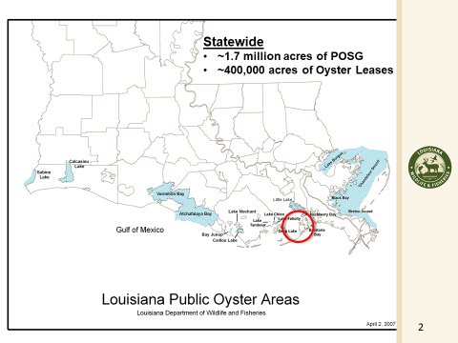
Authority to establish the new Public Oyster Seed Grounds is vested in the Wildlife and Fisheries Commission by R.S. 56:6(12) and R.S. 56:434(A). This NOI will create a new section in Title 76 under Chapter 5 Oysters.
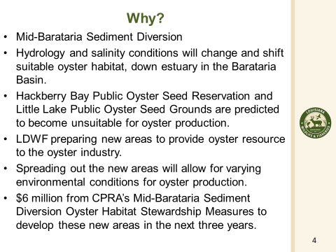
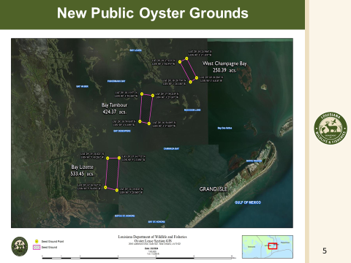
Criteria for new POSGs:
- Open and unused state water bottoms.
- Area that is in LDH open and approved harvest areas
- Firm or hard benthic substrate
- Oyster larval recruitment
- Oysters survive under current conditions
- Oysters likely to survive under future conditions
- Will locations be approved for Coastal Use Permits
- Is there current harvest in these areas

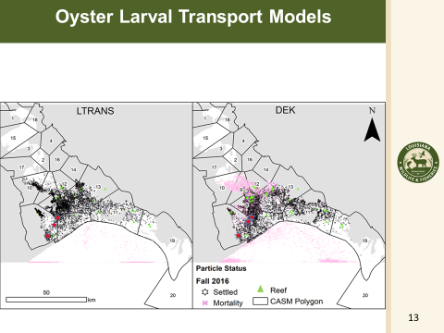
Here are two Oyster Larval Transport models, using Fall 2016 data to show oyster settlement after 30 days in the lower Barataria Basin. I put red stars over the approximate location of the future public oyster grounds. Dekshenieks (DEK) model, named after the researcher who made the model. The Lagrangian TRANSport model (LTRANS). The two models make different assumptions on how to represent movement behavior and growth/development, including important differences on how these depend on salinity and temperature. The models show that these areas for the POSG will have high potential recruitment. (However, this is based on 2017 data published December 2023-Pre-MBSD conditions/ Distribution on Day 30 in Fall 2016 of oyster larval particles in LTRANS and DEK.)
(LATIG funded modeling: Testing DEK and LTRANS for Simulating Oyster Larval Transport and Recruitment Success in Barataria Basin)
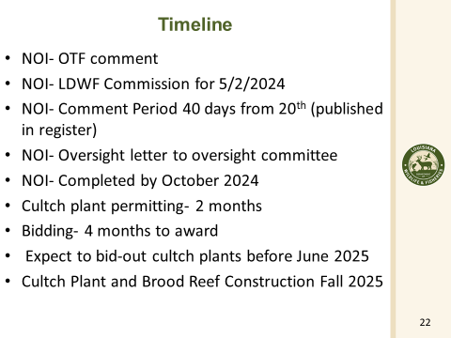
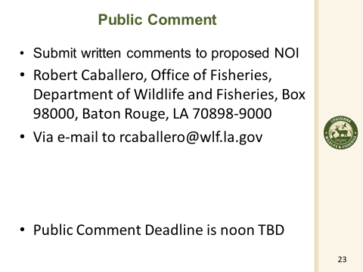
Mitch Jurisich states that he would like to see more accurate information on how these oysters are being harvested; AOC or intertidal coon oysters, etc.
Jakov Jurisic expressed concern for planting on sandy bottoms
Steve Pollock motioned to approve designating the proposed state water bottoms as a public oyster seed grounds in Lafourche Parish, 2nd by Mitch Jurisich. Motion did not carry.
The task force would like more time to consider this item, requested to take this item up again at their next meeting for a vote
C. Task force discussed HB 342 that would prohibit AOC containers in unapproved areas
Al Sunseri stated that 2 years ago go some people complaining about oysters being held in some closed areas and sold in Jefferson Parish. Mentioned this to different officials at LDWF and sometime in the 3-4 quarter of 2023 notified by oyster industry that there was some illegal harvesting in closed and prohibited areas and different agencies were notified in October. In later part of November got a call about trying to do something about this, there is a health concern. Asked to set up a meeting with FDA, LDH and LDWF to discuss this further and worked through NSSP and what the concerns were and what can be done. Strickly an issue with market sized oysters being put in containers that make it ready and able to be sold immediately.
Steve Pollock stated that he thinks this is an education issue more than anything, we need outreach by LDH and LDWF to educate the industry about putting any oysters that are over an 1” in unapproved areas, it is illegal, the bill is too general, need more specific information in the bill; present law provides that when a vessel is found to be harvesting within an unapproved or closed area, all oysters on board the vessels shall be deemed to have been taken from unapproved or closed water, and shall be deemed to constitute a hazard to the safety, health, and welfare citizens state.
Mitch Jurisich asked that Steve Pollock work with Al Sunseri to rewrite the bill to address issues
LDH issue with emergency procedures that some of the AOC have, haven’t seen this in the emergency plan but there may be issue during a hurricane when everything is closed, may need to add something in the bill about emergency procedures
Al Sunseri stated that he will ask Rep. Zeringue to pull this bill since it has been stated that there are enough laws on the books to enforce this already
Mitch Jurisich stated that he would suggest that Al Sunseri work with the OTF legislative committee to iron some of this out for next legislative session or a special session
D. Steve Pollock led discussion on the profitability of the caged oyster culture industry in LA
The economic feasibility study completed by Dan Patrolia from MS State applied for board chair for 6 months and received it. The report summarizes by saying that consistent with the findings of previous analyses in the literature, I find that the average small scale operation is not expected to be profitable. In my analysis I estimate that it is generally necessary to operate at or above levels of 720,000 oysters planted on 3 acres to realize positive average annual profit. And that statement also says, even with or without, a 45,000 subsidy, which was the amount of the LSU Sea Grant awards that were handed out these past several years. The Grant monies from the State were meant to kick start additional interest in caged oyster call through in Louisiana. It was not meant for these individuals to go in and be profitable in their first year, but some of them have done that. What I fear is that policy decisions will be made for further funding to fund or to not fund or support the expansion of AOC in the presence or the absence of a freshwater diversion from the Mississippi River. I think it's going to exist whether or not those funds come our way. But the small guys have a role in this funding the small farms, allowing them to make decisions to grow as a business. If the money's going to go somewhere, I'd love to see it go to the fishermen that really need it, that want to do it. Some of them are commercial fishermen, as I mentioned, that are now going into AOC.

Earl Meloncon stated that next month at the task force meeting he will be providing an executive summary of the AOC Grant Program and will address some of these issues
Gene Cavalier stated that the Certified LA Program would love for Steve Pollock to come to their office and meet with them
E. Mitch Jurisich provided an update on the status of the Mid- Barataria Sediment Diversion
There are several lawsuits out there, one of them filed on the environmental side of the things in the Federal Courts. Plaquemines Parish also had flood plain issues with the diversion and ultimately filed a lawsuit as well. The parish courts ruled to do a stop work order to CPRA because of some FEMA regulation issues, CPRA put injunction against the parish saying you can not stop work on this project, in the mean time the parish filed a suit in the First Circuit Court of Appeals, Baton Rouge should not have taken a ruling since there was already a case in Plaquemines, appealed with the 4th circuit court of appeals judge ruled that it does belong in Plaquemines Parish, Plaquemines Parish took steps to again put in a stop work order until further rulings come in from the judges, working with administration to figure out what next steps are going to be
F. John Bennett provided a presentation on a marketing opportunity with Fox-8
NOLA Now segment, 3-4 minute extended segments- educate the public, behavioral targeting
Mitch Jurisich stated that he would like to see the figures at an upcoming meeting and time frame, would like to look at this further; would like to make note to add an agenda item for the next meeting; John stated that he should have something by May
Jakov Jurisic stated that he would like to see different packages with prices associated, also would like to come and talk to Seafood Promotion and Marketing Board to discuss this further
G. Drayton Agnew provided an update on the virus/ bacteria RT-PCR laboratory testing and isolation, believes companies should be investigated
Mitch Jurisich suggested that Steve Pollock and Drayton get together and discuss further and bring a simpler version back to the task force for discussion
H. Peter Vujnovich led discussion on RHB Production’s documentary on the BP Oil Spill and the aftermath, would like the task force’s support to continue this documentary, write letters of support to the SPMB/ office of tourism to encourage their support for these videos; may come provide a presentation in the future
Jakov Jurisic motioned to write letters of support and to request funding support from the Seafood Promotion and Marketing Board and the Office of Tourism for the continued work on RHB Production’s documentary that covers the BP Oil Spill and the aftermath, 2nd by Brad Robin. VII. Public Comment
VII. Public Comment:
George Ricks stated that Brad Robin and I met with state Representative Bayham, update on Caernarvon, supposed to operate by 15 PPT from December –May 14 day moving average salinity, because of failed Bohemia Salinity Control Structure, stays low most of the year and CPRA has a tough time operating under these conditions so they went to a 10-year, ran Feb 1-16 and decided to turn on on March 8, post larval brown shrimp in Black Bay in Feb and ramp up populations in March and April, right now 42K cfs, in my opinion killing post larval brown shrimp, this operational plan for Caernarvon is antiquated, the plan is failing and needs to be changed suggested that the task force make a resolution or write a letter to get WLF more actively involved in this operation, failing on the objective
VIII. The next meeting is set for Tuesday, April 30th Wednesday, June 12 for 10:00am at the new Orleans Lakefront Airport
IX. Brad Robin motioned to adjourn the meeting, 2nd by Peter Vujnovich. Motion carries.

